**DAILY ONLINE ACTIVITIES SUMMARY**

|  |  |  |  |  |  |  |  |  |
| --- | --- | --- | --- | --- | --- | --- | --- | --- |
| **Date:** | **20/05/2020** | | | | | **Name:** | **Felina Menezes** | |
| **Sem & Sec** | **4th SEM 'A' Section** | | | | | **USN:** | **4AL18CS021** | |
| **Online Test Summary** | | | | | | | | |
| **Subject** | | **Object Oriented Concepts** | | | | | | |
| **Max. Marks** | | **30** | | **Score** | | | **18** | |
| **Certification Course Summary** | | | | | | | | |
| **Course** | **1.Python In Machine Learning** | | | | | | | |
| **Certificate Provider** | | | **1. Great Learning Academy** | | **Duration** | | | **1. 50 min** |
| **Coding Challenges** | | | | | | | | |
| 1. **Problem Statement: 1.** Using methods charAt() and length() of string class, Write a program to print the frequency of each character in a string.   “Hello friend”   1. A user will input two strings, and we find if one of the strings is a sub sequence of the other. Program prints “yes” if either the first string is a sub sequence of the second string or the second string is a sub sequence of the first string. 2. Given an array a [] of size n which contains elements from 0 to n-1, write a program print Duplicates which prints the duplicate elements of the given array. If no duplicate element is found print -1. 3. Write a C Program to Reverse a Linked List (SLL) in groups of given size. | | | | | | | | |
| **Status: completed** | | | | | | | | |
| **Uploaded the report in Github** | | | | | **Yes** | | | |
| **If yes Repository name** | | | | | https://github.com/felinamenezes/lockdown-coding.git | | | |
| **Uploaded the report in slack** | | | | | **Yes** | | | |

ONLINE TEST DETAILS: Online test was conducted on the first module of Object Oriented Concepts. Test contains 20 questions of 1 Mark each and 10 questions of 2 Mark each.

Snapshot:

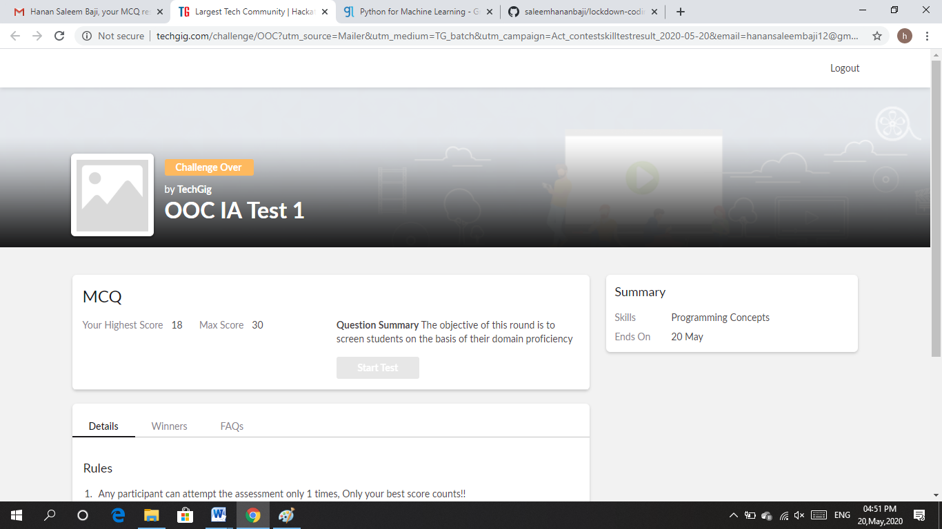

Certification Course Details: In third day of Python in Machine learning course, topics covered are conditional statement, loops and some other functions. It has explained how this conditional statement, loops are used in Python and its working.

Snapshot:

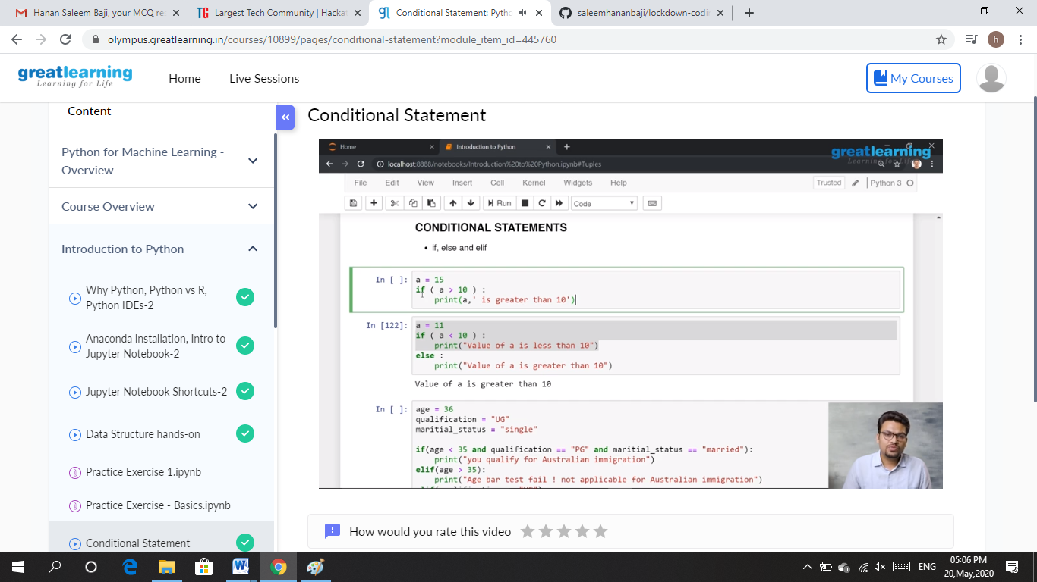

CODING CHALLENGES DETAILS: Problem statements

1. Using methods charAt() and length() of string class, Write a program to print the frequency of each character in a string.

“Hello friend”

Output should be

-: 1

d: 1

e: 2

f: 1

(continued for all character in the string)

Solution : Uploaded it in github

Snapshot:

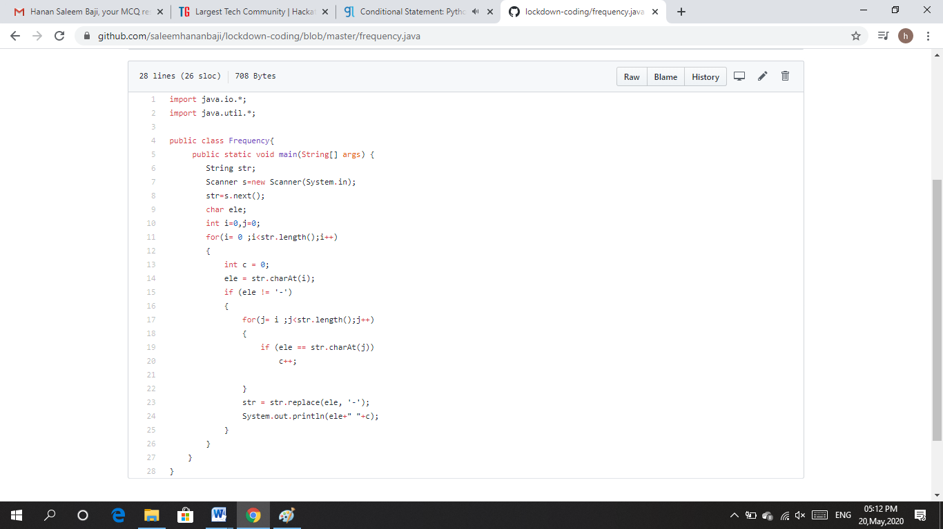

1. A user will input two strings, and we find if one of the strings is a sub sequence of the other. Program prints “yes” if either the first string is a sub sequence of the second string or the second string is a sub sequence of the first string.

Assume that, the length of the first string is smaller than or equal to the length of the second string.

Solution : Uploaded it in github

Snapshot:

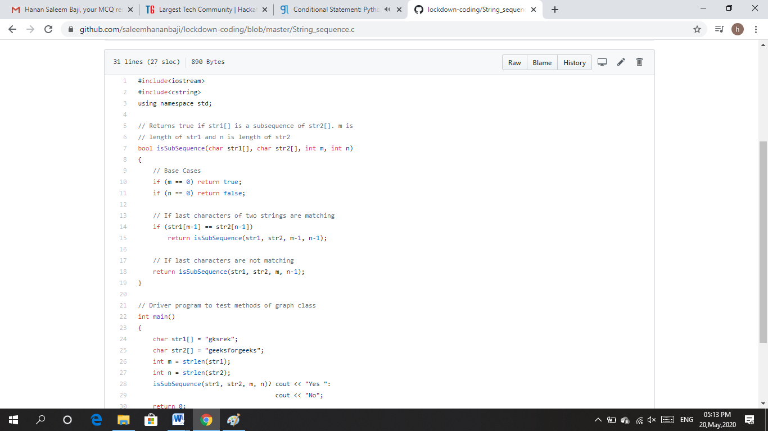

1. Given an array a [] of size n which contains elements from 0 to n-1, write a program print Duplicates which prints the duplicate elements of the given array. If no duplicate element is found print -1.

Input:

The first line of input must contain an integer n which denotes number of elements of Array. Second line contains n space separated integers denoting elements of array a [].

Output:

Print the duplicate elements from the given array

Solution: Uploaded it in GitHub

Snapshot:

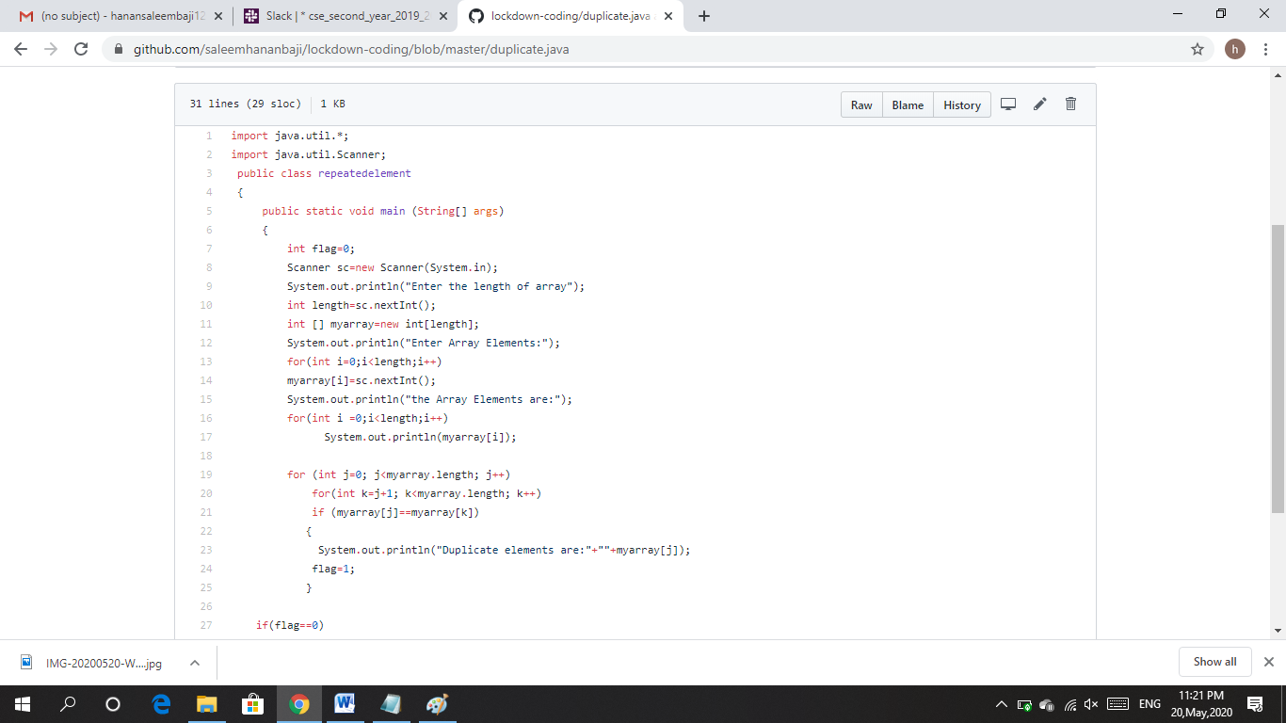

1. Write a C Program to Reverse a Linked List (SLL) in groups of given size.

Test Case 1:

If a linked list is: 1 → 2 → 3 → 4 → 5 → 6 → 7 → 8

The value of size k is 2

Then the linked list looks like: 2 → 1 → 4 → 3 → 6 → 5 → 8 → 7

Test Case 2:

If a linked list is: 1 → 2 → 3 → 4 → 5 → 6 → 7 → 8

The value of size k is 3

Then the linked list looks like: 3 → 2 → 1 → 6 → 5 → 4 → 8 → 7

Solution: Uploaded it in GitHub

Snapshot:

